**Random Sample generator**

**Introduction:**

This Python script demonstrates the process of generating random sample input data and making predictions using a pre-trained machine learning model for credit card fraud detection. Leveraging the scikit-learn library and pandas for data manipulation, the script generates synthetic data, predicts the likelihood of fraud, and appends the results to an Excel file for further analysis.

**Purpose:**

The purpose of this script is to simulate real-world scenarios by generating random input data and evaluating the model's performance in detecting fraudulent transactions. By repeatedly generating new data and making predictions, it allows for robust testing and validation of the fraud detection model's effectiveness and scalability.

*Implementation:*

- *Model Loading and Prediction*: The script loads a pre-trained machine learning model for credit card fraud detection using joblib. It defines a function to make predictions based on input data and another function to print the prediction result.

- *Data Generation and Prediction:* For each iteration (100 iterations in this case), the script generates random sample input data resembling credit card transaction details. It then utilizes the deployed model to predict whether the transaction is fraudulent or legitimate. Prediction results are printed, indicating the classification outcome.

- Result Logging: After each prediction, the script appends the input data along with the prediction result (fraud or legitimate) to an Excel file named 'predictions.xlsx'. If the file exists, it loads the existing predictions and appends the new results. If the file does not exist or encounters an IO error, it creates a new file to store the data.

*Conclusion:*

This script provides a convenient and efficient way to evaluate the performance of a credit card fraud detection model using randomly generated sample data. By iteratively generating data and making predictions, it enables thorough testing and validation of the model's accuracy and robustness. Additionally, logging the prediction results to an Excel file allows for further analysis and comparison of model performance over time.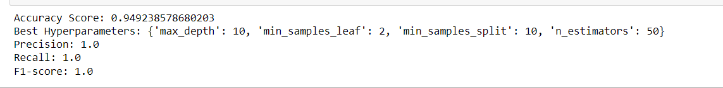

**Model Validation:**

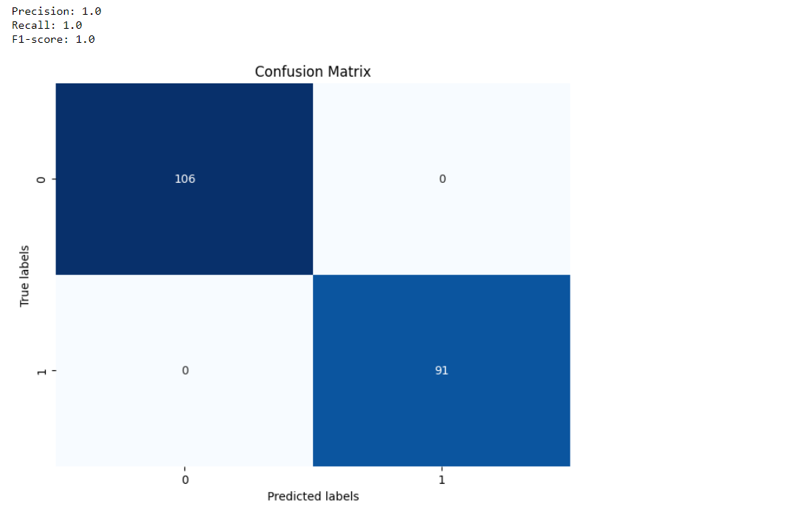

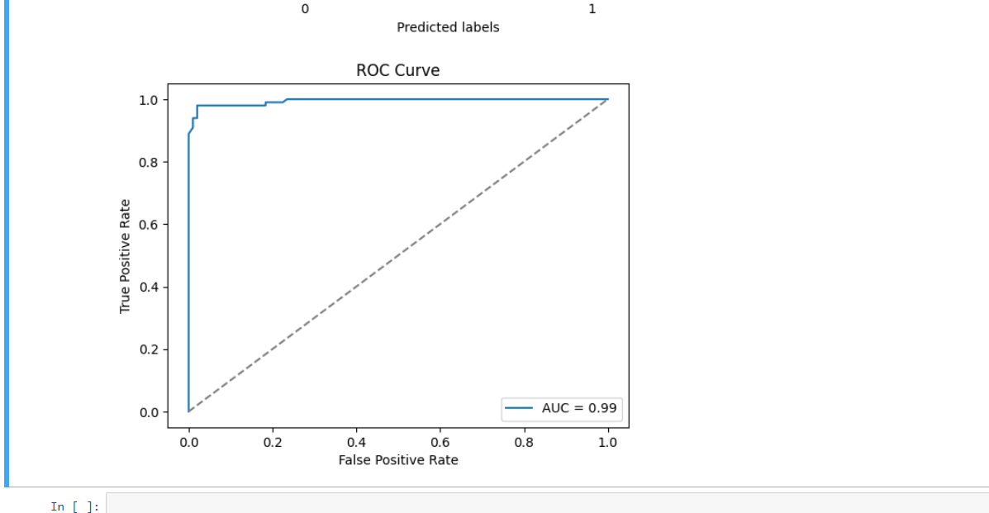

**Future Work**

In the pursuit of improving our credit card fraud detection system, several potential areas for future exploration and enhancement have been identified:

1**. Feature Engineering**: Experimenting with different feature engineering techniques can offer insights into potentially more informative representations of the data, leading to improved model performance.

2. **Model Selection**: Evaluating alternative machine learning algorithms and ensemble methods beyond the RandomForestClassifier utilized in the current pipeline may uncover models better suited to capturing the complexities of the dataset.

3. **Ensemble Methods:** Exploring ensemble methods such as bagging, boosting, and stacking provides opportunities to combine multiple models effectively, potentially yielding higher predictive accuracy.

4**. Data Augmentation**: Investigating data augmentation techniques, such as synthetic sample generation with methods like SMOTE (Synthetic Minority Over-sampling Technique), may help address class imbalance and improve model generalization.

5**. Advanced Hyperparameter Tuning:** Delving deeper into hyperparameter tuning by leveraging advanced optimization techniques like Bayesian optimization or genetic algorithms can further refine model performance.

6. **Deployment**: Transitioning the developed model into a production environment involves integrating it seamlessly into existing systems, ensuring scalability, reliability, and real-time performance monitoring.

7. **Continuous Improvement:** Establishing a framework for continuous model improvement involves periodic retraining on new data, incorporating user feedback, and adapting to evolving fraud patterns and detection requirements.

By exploring these areas, we aim to enhance the effectiveness and robustness of our credit card fraud detection system, providing better protection for our customers and their financial assets.